



Business Requirement Document
Supply Chain Management
NWS Tendering Strategy
DOCUMENT FOR

Table of Contents:
Table of Contents: 1
1. Introduction 2
1.1 Business Need 2
1.2 Expected Business Outcomes 2
1.3 Project Scope Summary 2
2. Business Requirement Details 3
2.1 Requirement Description 3
Header Fields 3
2.2 Functional Tabs 4
2.3 Workflow & Approval Process 4
3. System Integration 4
4. Non-Functional Requirements 5
5. Process Flow 5
6. Assumptions & Constraints 5
7. Risks & Mitigation 6
8. Report 6
9. Application Prototype 6
10. Open and Close Issues 8
10.1 Open Issues 8
10.2 Closed Issues 8

1. Introduction

1.1 Business Need
Currently, Nama Water Services executes its tendering strategy called as previously “MOM” through online E- Forms in Apex. To streamline and digitize this process, a Custom Tendering Strategy Application will be developed and integrated into Oracle Fusion SCM. This application will enable users to create, review, and approve tendering strategies directly from the Oracle Fusion Work Area, ensuring alignment with procurement governance and transparency requirements.

1.2 Expected Business Outcomes
- Streamlined and automated tendering strategy creation and approval.
- Improved visibility into tendering activity and approval status.
- Enhanced data accuracy through integration with Oracle Fusion Supplier Master and PR details.
- Reduction of manual data entry and paper-based workflows.
- Audit trail for tender creation, modification, and approvals.

1.3 Project Scope Summary
The project includes:
- A Custom Tendering Strategy Work Area accessible via Oracle Fusion SCM.
- Capability to create, review, and approve tendering strategies.
- Integration with Purchase Requisition (PR) and Supplier Master.
- Implementation of an approval workflow with statuses such as Submitted, Approved, Rejected, and Withdrawn.
- Attachment handling, logging, and audit history.

2. Business Requirement Details

2.1 Requirement Description
When the end user clicks the Tendering Strategy icon in the Oracle Fusion Work Area, the system will navigate to a Tendering Strategy Summary Page displaying all existing strategies with fields such as Tendering Strategy Number, Objective, Status, Creation Date, and Creator. Users can click Create Tendering Strategy to initiate a new record.

Header Fields
Field Name | Description | Behavior
Tendering Strategy Number | Unique auto-generated number | System generated
Creator | Auto-populated based on login | System generated
Objective | Purpose of the tender (240 characters) | User input
Part of Procurement Plan | Dropdown (Yes/No) | User selection
Justification | Visible only if Part of Procurement Plan = No (1000 characters) | Conditional field
Background | Unlimited text area | User input
Summary of Scope of Work | Unlimited text area | User input
PR Number | Integration with Oracle Fusion PR | Select/Search
Attachments | Upload files (PDF, DOCX, XLSX, ZIP) | User input

2.2 Functional Tabs
The application screen will contain multiple tabs:
• Technical Line Details – Add multiple lines (Title, Line Description, Quantity).
• General Requirements – Text area for requirements.
• Risk Assessment – Text field for risk identification.
• Cost Estimate – Grid for S. No, Description, Quantity, Unit Price, and Total Cost.
• Technical & Commercial Criteria – To enter the List of requirements and Separate fields for remarks in the footer.
• Supplier List – Data fetched from Oracle Fusion Supplier Master.

2.3 Workflow & Approval Process
Once the user completes the data entry, they can submit the strategy for approval. The workflow includes actions such as Approve, Reject, and Withdraw. The approval status will be displayed at the header level, and routing will follow the Oracle BPM workflow configuration with audit trail for each action.

3. System Integration
System | Module | Integration Point | Description
Oracle Fusion SCM | Procurement | Tendering Strategy Work Area | Access and launch of custom page
Oracle Fusion Procurement | Purchase Requisition | PR number linking and data retrieval
Oracle Fusion Supplier Master | Supplier Information | Fetch supplier list and details
Oracle Fusion Workflow | Approval Routing | Manage approval actions and history

4. Non-Functional Requirements
- Security: Role-based access and HTTPS encryption.
- Performance: Response time < 3 seconds.
- Scalability: Multi-user concurrent access.
- Audit: Logs of user actions and timestamps.
- Availability: 99.5% uptime.

5. Process Flow
1. User navigates to Oracle Fusion SCM Work Area.
2. Clicks the Tendering Strategy icon.
3. Lands on the Summary Page displaying all strategies.
4. Clicks Create Tendering Strategy.
5. Fills header and line details.
6. Adds attachments and submits for approval.
7. Workflow approval or rejection.
8. Status updated in the header section.

6. Assumptions & Constraints
- Access restricted to authorized users, based on admin roles and user roles
- Integration with Fusion PR and Supplier APIs.
- Attachments limited with Maximum Capability.
- Approval handled via Custom Mail Notifications.

7. Risks & Mitigation
Risk | Impact | Mitigation
Workflow delay | Approval bottleneck | Enable escalation alerts
Integration failure | Missing supplier or PR data | Implement retry logic
Unauthorized access | Data exposure | Use role-based access
Performance issues | User dissatisfaction | Optimize backend queries

8. Report
Below attached report is the Output PDF of Tendering Strategy.

9. Application Prototype
Prototype screens for Summary, Header, and Tabs are shown below separately.
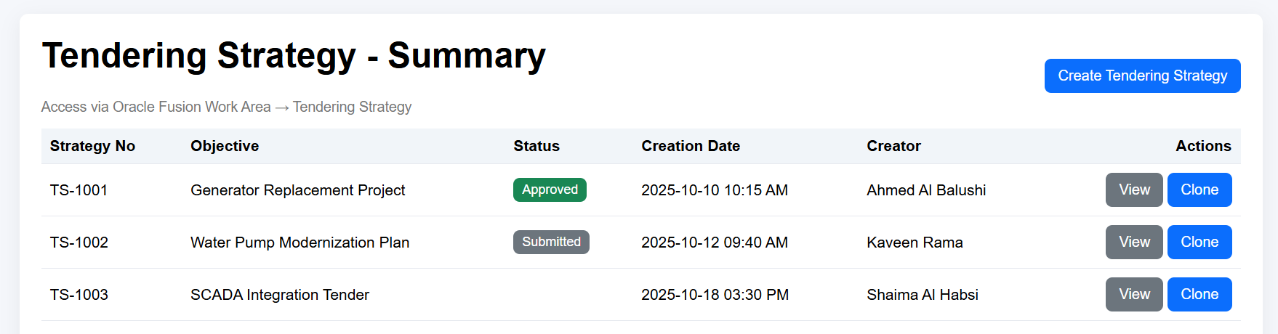
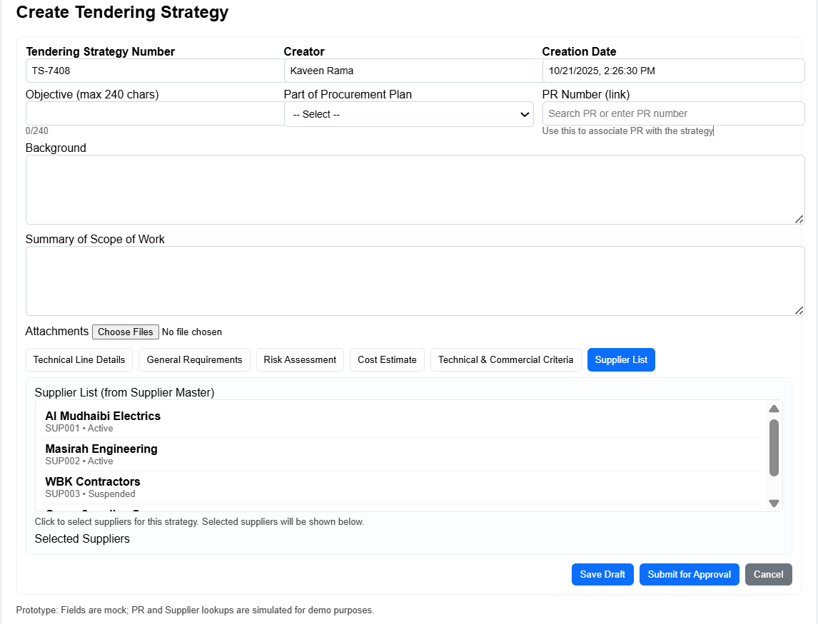

10. Open and Close Issues

10.1 Open Issues
S. No | Issue | Resolution | Responsibility | Target Date | Impact Date
1 | Define approval matrix | To be finalized with SCM and Procurement | NWS SCM Team
2

10.2 Closed Issues
S. No | Issue | Resolution | Responsibility | Target Date | Impact Date
1
2

